Coordination chemistry of functionalized benzothiadiazoles and their analogues

D.A. Bashirov^{a,b}, T.S. Sukhikhª, R.M. Khisamov^{a,b}, E.K. Pylova^{a,b}, D.S. Ogienkoª,
S.N. Konchenko^{a,b}

ªNikolaev Institute of Inorganic Chemistry SB RAN, Novosibirsk, RUSSIA.
^{b}Novosibirsk State University, Novosibirsk, RUSSIA.

Molecular materials containing a 2.1.3-benzothiadiazole (btd) unit attract an attention mainly due to the intensive luminescence. That encourages synthesis of new organic derivatives of btd, and study of their photophysical properties. At the same time, coordination chemistry of btd-based ligands is still limited with few complexes, containing unsubstituted btd or its derivatives with such simple functional groups as -NH₂, -OH or -COOH [1-6].

This report is focused on an overview of our ongoing study devoted to the synthesis, complexation and photophysical properties of new btd-based ligands containing more advanced functional groups. Some representative examples of the ligands and the complexes obtained are shown in the scheme 1.

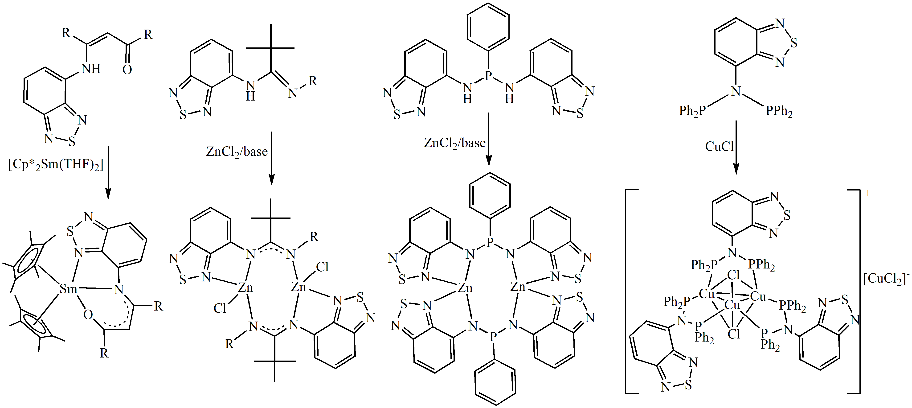

Scheme 1. Examples of some functionalized 2.1.3-benzothiadiazoles and the complexes with them.

[1] T.S. Sukhikh, D.A. Bashirov, D.S. Ogienko, N.V. Kuratieva, P.S. Sherin, M.I. Rakhmanova, E.A. Chulanova, N.P. Gritsan, S.N. Konchenko and A.V. Zibarev, RSC Adv., 2016, 6, 43901-43910.
[2] T.S. Sukhikh, D.A. Bashirov, D.S. Kolybalov, A.Y. Andreeva, A.I. Smolentsev, N.V. Kuratieva, V.A. Burilov, A.R. Mustafina, S.G. Kozlova and S.N. Konchenko, Polyhedron, 2017, 124, 139–144.
[3] T.S. Sukhikh, D.A. Bashirov, S. Shuvaev, V.Y. Komarov, N.V. Kuratieva, S.N. Konchenko and E. Benassi, Polyhedron, 2018, 141, 77-86.
[4] T.S. Sukhikh, V.Y. Komarov, S.N. Konchenko and E. Benassi, Polyhedron, 2018, 139, 33-43.
[5] T.S. Sukhikh, D.S. Ogienko, D.A. Bashirov, N.V. Kuratieva, A.I. Smolentsev and S.N. Konchenko, Koord. Khim., 2019, 45, 32-37. (Коорд. Хим., 2019, 45, 32–37)
[6] T.S. Sukhikh, D.S. Ogienko, D.A. Bashirov and S.N. Konchenko, Izv. AN. Ser. Khim., 2019, 651-661. (Изв. АH. Сер. Хим., 2019, 651-661)

Acknowledgements – Authors thank RFBR (projects 16-03-00637 and 19-03-00568) and Ministry of Education and Science of Russian Federation for financial support.

e-mail: konch@niic.nsc.ru

